NTARE DEUS

TEL. +250 788641800

+250 788513817

P. O. BOX 2707 WDA Kigali Rwanda

Email: nteradet@yahoo.com

Marital Status: Single · Nationality: Rwandan

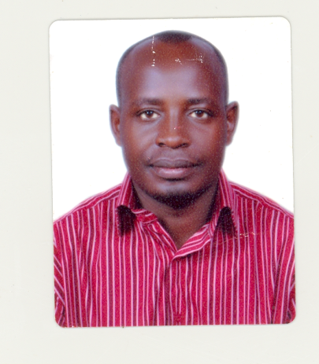

I have a strong preference for Hotel Management and Operations, and three years of Human Resource management in Hotel Industry, I am motivated as a self starter, hardworking and always keen on leaving a mark of excellence in everything that passes through my hand. I also have a keen eye for detail and projecting a positive and professional image at all times.

Human resource & administration manager in Hill Top Hotel two stars in Rwanda. I am in second semester pursuing my Masters degree in Business administration in Hotel Management in field of Marketing and graduating this year.

EDUCATION & CERTIFICATES OBTAINED

2012 Les Roches International school of Hotel Management Switzerland MBA

2009-2009 ORITON Hospitality institution in Singapore Certificates

2001-2006 KIST and SFB Management in Rwanda BBA

1999-2000 Apred Ndera Secondary School in Rwanda Diplomas

1995-1998 Solidarity Academy secondary in Rwanda diplomas

1985-1991 st Kizito Primary School Uganda Certificate

Description of duties and responsibilities

- Developed modules for the specific trainings in Hospitality Industry
- Identified trainings and development needs within the country through monitoring and evaluating training centers and Hotels
- Designed and developed trainings and developing programs based on both the Hospitality industry and market needs
- Working in a team to produce programs that are satisfactory to all relevant Hospitality Departments in our training centers, such service Department, Front office, Housing keeping and Culinary Art
- Keeping up to date with developments in training by setting up relevant schedule and attending relevant courses regarding improving customer care
- Having an understanding of e-learning techniques, and where relevant, being involved in the creation and delivery or e-learning packages conducting appraisals a developing effective induction programs

OTHER TECHNICAL EXPERTISE

- Prepare and administer the Hotel annual operating activates
- Administer the departmental operating improvements
- Hotel Sales and Marketing
- Ensure the application of Hill top Hotel policies and procedures in collaboration with Director General.
- Ensured the effective co-ordination and implementation of all administrative and customer care operations in the line with Hotel policies and procedures.
- Able to engage effectively with the Hotel systems, manage and manipulate data as will be required on a time to time basis.
- Ensured that proper customer care practices are followed and up –to date records are kept
- Ensured that new staff gets all the relevant inductions, training and support from relevant key staff.
- Implemented the hotel performance management system with relevant staff and with the support of the director.
- Carry out training and capacity building of staff, either by carring these out using existing materials or identifying alternative sources for training.

INTERESTS
- Golf
- Travelling
- Community Service

REFERENCES

1 . Dr Dimitrios Diamantais
MBA PROGRAM MANAGER
Email: dimitrios.diamantis@lesroches.edu

2. KALISA JOAN
HUMAN RESOURCE SPECIALIST PRIME MINISTER`S OFFICES
TEL: +250 788406921

3. COLONEL, MUGANGA ALOYSIA
TEL: +250 788305980
+255 757444308

4: Mr. Munezero Didier
Director of Partnership (WDA)
+250 788303726

